COM IDENTIFICATION SHEET
Please use this form to help identify your COM, as well as the application of the COM

We will presume that all COM is first quality fabric. Therefore, we shall not assume the responsibility for any imperfection in the fabric before or after cutting.
Younger will use their judgment on applying COM cover unless otherwise noted below. To help determine the correct cutting standard for your material see the drawings below. There are two ways of “topping” which are termed “Railroad” and “Non railroad.” Railroad is “topped” to the edge of the fabric and Non railroad is “topped” into the roll. All COM will be cut major motif in a vertical manner unless specified otherwise, including stripes and textures.
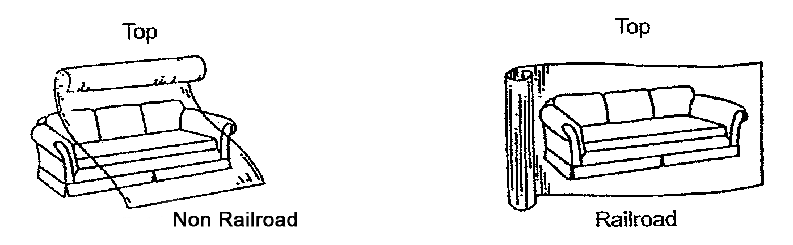

The chart below has been calculated to accurately cover the greatest majority of COM orders. Because of unusual pattern or proportions and designs of an individual piece, there may be some instances where additional yardage will be needed. When fabric width is less than needed, seaming will be necessary.

Railroad COM requirements:
FABRIC WIDTH | PLAIN FABRIC | 1"-15" REPEAT | 16"-27" REPEAT | 28"-36" REPEAT
54" | 0% | 20% | 35% | 50%

** For any fabric that is non-railroad, add 40% to the above requirements
** Yardage for COM welt is 4 yards, regardless of style or fabric
** To calculate the number of square feet of leather needed on a piece, multiply the yardage listed in the pricelist by 20

Please complete the information below and attach a sample of each COM with face side clearly marked. Younger will expect face side to be rolled to inside of roll.

DEALER NAME __________________________________________________________ DATE ________________

PURCHASE ORDER # __________________ TAG ___________________________________________________

COM SOURCE/FABRIC ID CODE___________________________________________________________________

APPLICATION INSTRUCTIONS – RAILROAD OR NON RAILROAD_____________________________________

COM SOURCE/FABRIC ID CODE___________________________________________________________________

APPLICATION INSTRUCTIONS – RAILROAD OR NON RAILROAD_____________________________________

COM SOURCE/FABRIC ID CODE___________________________________________________________________

APPLICATION INSTRUCTIONS – RAILROAD OR NON RAILROAD_____________________________________

SHIP FABRICS TO: YOUNGER FURNITURE
110 TODD COURT
THOMASVILLE, NC 27360

**PLEASE ATTACH A COPY OF THIS FORM TO YOUR PURCHASE ORDER AND TO COM**
YOUNGER WILL NOT BE RESPONSIBLE FOR MATCHING UNIDENTIFIED FABRIC THAT IS RECIEVED

